AMB 200

Legacy Community Connect
Epic Hyperdrive 2024 & Orchard Harvest Client

WHA OB/GYN
Lab Assistant

Contents
Module 1: Epic Workflows 3
Exercise 1: Open the Citrix Receiver 3
Exercise 2: Log in to ACE1 4
Module 2: Basic Navigation and Functionality of Epic 5
Exercise 1: Hyperspace Toolbar 6
Exercise 2: Navigate to the other Workspace Tabs 8
Exercise 3: Multiple Provider Schedule 9
Module 3: Chart Review 15
Exercise 1: Getting up to speed on your patient 15
Module 3: Lab Appointment Prep 20
Exercise 1: Finding & Releasing Lab Orders 20
Exercise 2: 1 Hour Glucose Tolerance Test 23
Exercise 3: Pre Charting – 3 Hour Glucose Tolerance Test 26
Module 4: Lab Appointment Documentation 29
Exercise 1: 3 Hour Glucose Tolerance Test Documentation 29
Exercise 2: Nurse Visit & Clinic Administered Medication Documentation 35
Exercise 3: Documenting an Immunization 45
Module 5: Access the In Basket 50
Exercise 1: In Basket Functionality Demo 51
Exercise 2: Create Staff Message 59
Exercise 3: How to Create QuickActions from the In Basket for Staff Messages and How to Use Them After Creation 61

Module 1: Epic Workflows

Exercise 1: Open the Citrix Receiver

Objective: To show learners how to access and log into the Epic system.
We will now log into the system and get started for the day.
In the clinic, you will click on one of two icons on the desktop:
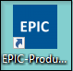 - Blue is the default access to the system.
- Click the blue Epic folder
- Then select the correct Hyperspace ACE _____.

*Notice the moon icon  at the bottom right side of the login screen, if clicked it will change the background of the Epic login screen.

Exercise 2: Log in to ACE1

Objective: To show learners how to understand and locate information specific for training.

Have new hires/students Login with their Tent Card information:
- User ID: WHAMA##
- Password: train
- Login Department: WHA TUALATIN [400147012]
- Message tip of the day; Click Ok

Module 2: Basic Navigation and Functionality of Epic

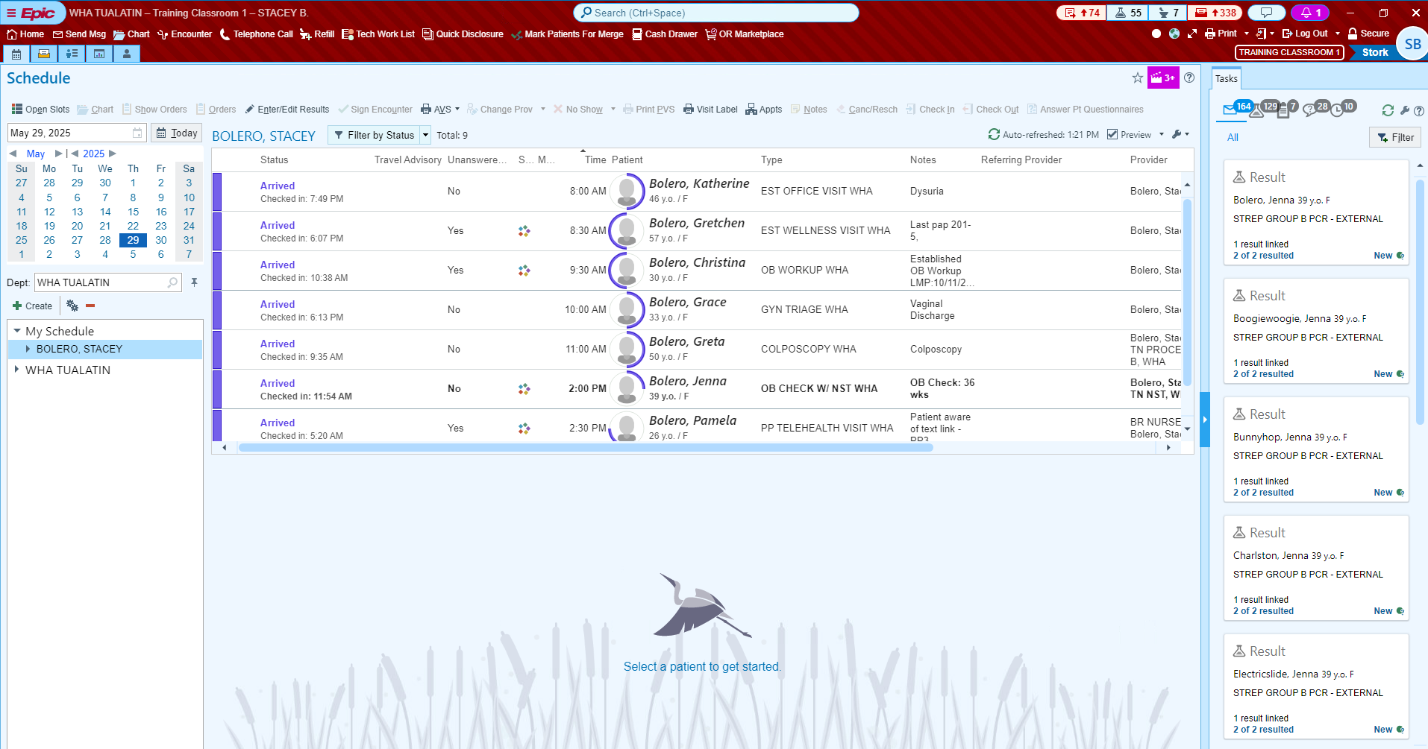

Exercise 1: Hyperspace Toolbar
Objective: Learner is comfortable with navigation and accessing specific activities.
These are common activities for your job role, available for quick access.
Epic button: Located on far left of the hyperspace toolbar. It contains your favorites, recent activities and less frequently used features. This is a lot like your All Programs button on your computer at home minus solitaire.
Home button: Takes you to your default home screen
Send Msg button: Begins the process to create a staff message.
Encounter buttons. Opens the Patient Lookup window to begin the process of starting an encounter

We will explore the other activities throughout the class, and others on this menu you may never use in your job role.
On the far right of the main menu, you will find a double-sided arrow, this indicates that you can enable compact mode.

To remove and add activities to our Hyperspace bar:
- In the hyperspace tool, Right click on my smartphrase and select remove.
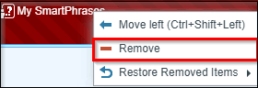
- Rearrange the icons by clicking on a tab and drag and drop to your preferred order.

Log Out/Secure 
Log Out button: Logs you completely out of Epic. Use for breaks, lunch or leaving for the day.
Secure button: Looks like a padlock. It prevents unauthorized access to the record (e.g. patients in unattended exam room). Also bookmarks the screen to open when signing back in. Secure is used whenever you leave the exam room, or whenever you leave your workstation.

My Settings 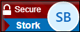
You can customize Epic to your personal preference from notifications to accessibility. You can also log out/ secure through this feature.
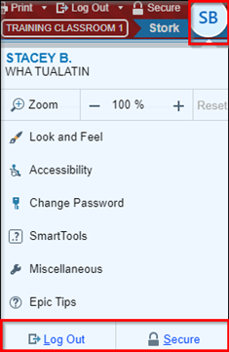

Exercise 2: Navigate to the other Workspace Tabs
Objective: Discuss how to navigate around Epic and what different activities are available for different workflows.
‘Hover’ over the workspace tabs to discover the tabs activity.
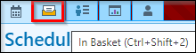
- Schedule tab: This displays daily appointment schedules for individual providers or for the entire department.
- In Basket tab: This represents the In Basket activity, which is the communication hub for clinician tasks.
- Legacy/My Dashboard tab: Click to find resources available under MyLegacy Intranet Links.
- Click the Schedule button.
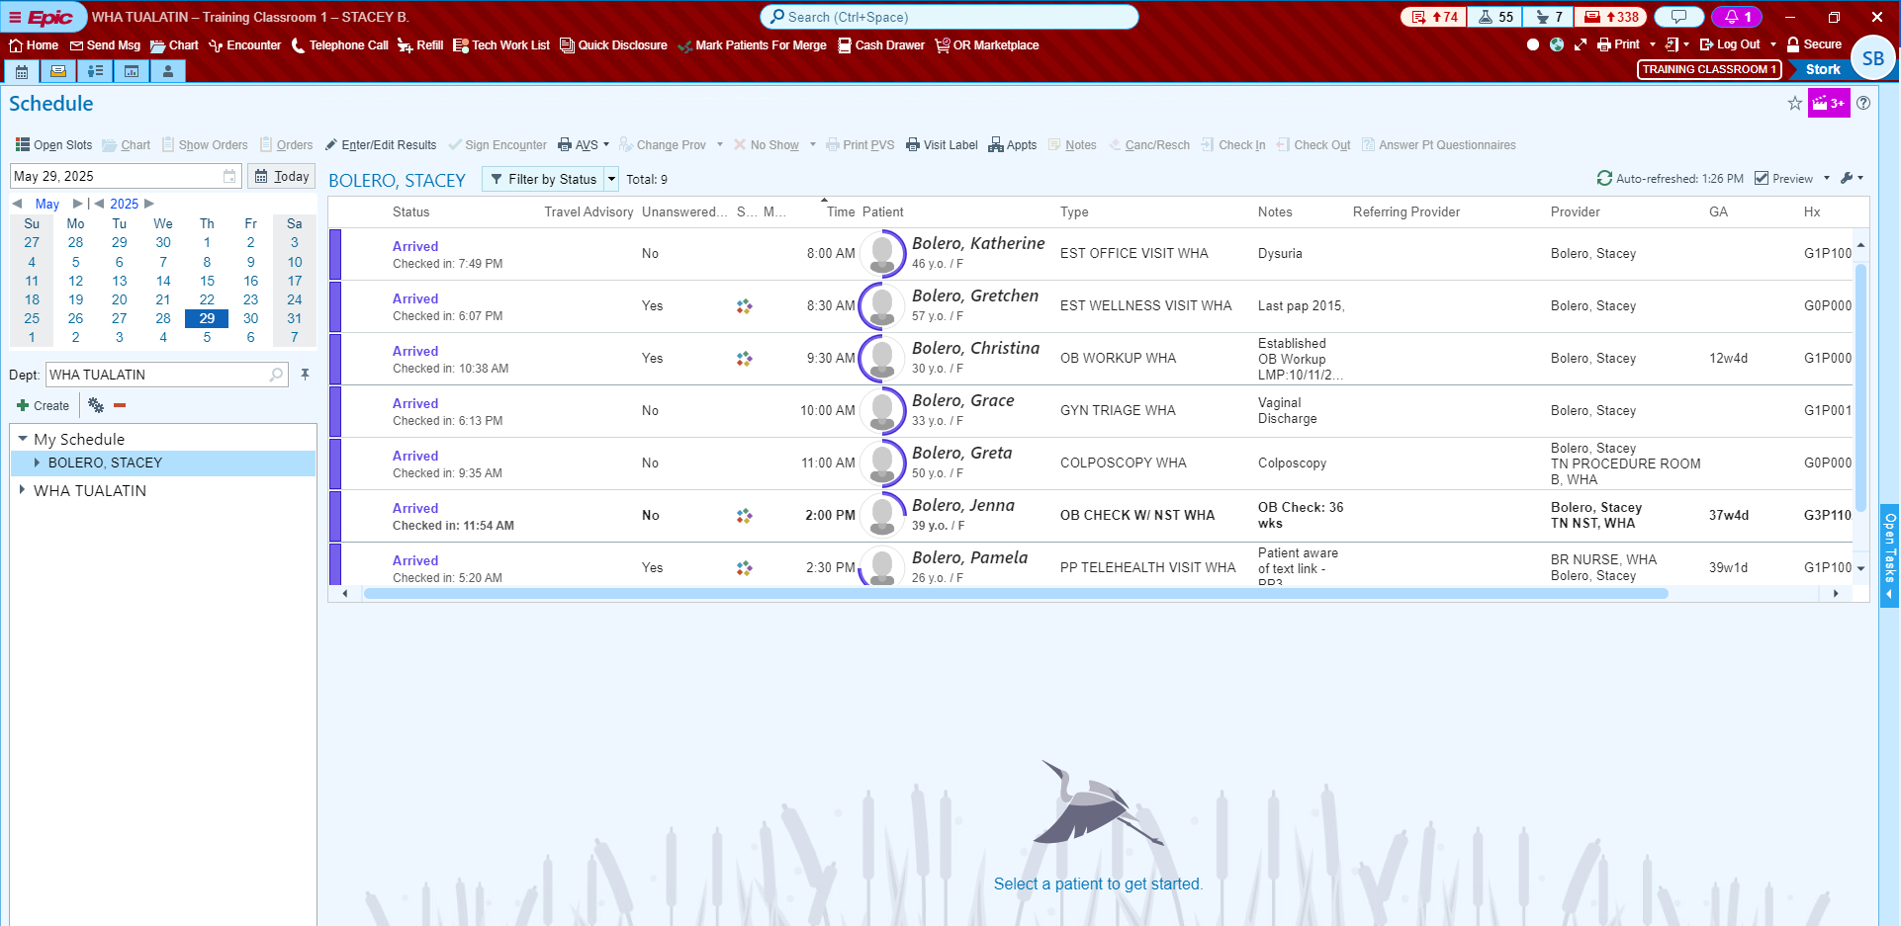

Exercise 3: Multiple Provider Schedule
Objective: Learner understands basic navigation and accessing specific activities.
Now we will explore the Schedule workspace.
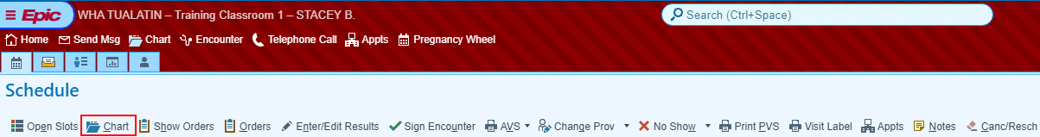
Activity buttons: specific to the activity or window currently viewing.
(Chart on main toolbar vs Chart in the Schedule activity.)
- Chart on Main toolbar opens the Patient Lookup window.
    - 3, 3 Rule - type the first three letters of the patient’s last name, and then first three letters of first name.
      - Example: Wes, Katherine for Katherine West
    - First three letters of first name (space) first three letters of last name.
      - Example: Katherine West
    - Phone Number: Type ph. (space) and phone number to locate patients from your caller id: (Example: ph. 971-555-1234)
- Chart above calendar on Schedule activity opens Chart Review for the patient you have highlighted on your schedule.
Calendar – 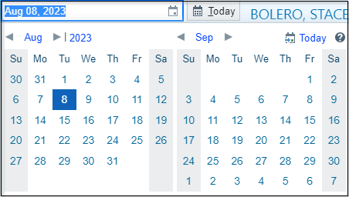 View scheduled patients for a specific day.
Department Folder – WHA TUALATIN
**Note: This does not change your login department! **
  - You can change the department here to view another clinic’s schedule.
  - To change your login department, click the arrow next to Log Out.

Click the arrow next to the WHA TUALATIN folder
Blue Folders – 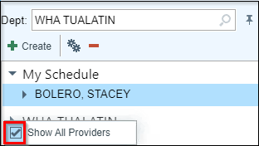 Ability to select specific schedules to view information.
Open folder and right click on ‘WHA TUALATIN’ then uncheck box to see only the providers who are in office that day.

All providers that could work in your department are now visible.
Now you can click on any provider listed and view their scheduled patients.
My Schedule – Stacey (8 patients)
The patients with scheduled appointments on the schedule will show on the right. At the top right of the schedule you can see the total # of patients, the last time the system refreshed itself, which is every 5 minutes, and a manual refresh (the are you here yet button).
You can drag and drop schedules from the Department schedules into your schedule to make the customization feature available.
Schedule appointment information section
- Blank Column: To flag the patient’s name with colored dots. Dots are visual cues that a task is ready to be done.
- Blue dots: This happens automatically when a procedure is ordered (POCT, immunizations, clinic administered medications).
- Yellow dots: This happens automatically when outpatient labs are ordered (x-rays).
- Green dots: This is manually changed when the MA/RN is finished with rooming the patient to signal to the provider that they are ready to be seen.
- Status Column: Displays the status of the patient with any descriptors above, also displays exam room when the rooming staff
- Scheduled: Patient has an appointment with provider for that day scheduled.
- Present: Patient is in the building but may be busy completing paperwork, is not ready to be called back from the waiting room.
- Arrived: Patient checked in, and is ready to be called back to the exam room.
- Visit in Progress: Patient is in the room with MA or Provider.
- Checked Out: Patient checked out at the front desk after an appointment.
- Signed: Provider has completed documenting visit and has sent to billing.
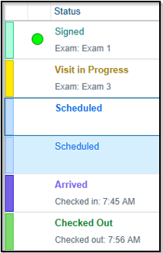
- Patient: Patient’s preferred name, age, and gender identity.
- Unanswered Questionnaires: Displays yes/no to indicate that the patient has unanswered history, series, and/or general questionnaires for an appointment.
- Same Day Visit: Displays an icon if the patient has any other appointments or cases scheduled on the same day as current visit.
- Meds Due Column: Red clock icon displays when Facility Administered Medications (FAM) are ordered. The icon hyperlinks to the MAR to document administration.
- Time: Scheduled start time of the visit.
- Type: Scheduled Visit Type (this can drive the different documentation tools, example: OB visit vs. GYN visit)
- Notes: “Why” the patient is coming in to be seen.
Preview Report pane (right section of the window)
Single click the Gretchen patient to view the Report section.
The Preview Pane can be toggled on or off by clicking the Check box in the upper right side of the Schedule Workspace.
Click the drop down arrow to change the position of the Preview Pane report.
Notice the Auto-position box is checked. To create more space to view the columns on the schedule, click the Bottom box. Now, there is more real estate to view the schedule and more information is easily visible.
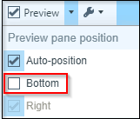
OB Snapshot is the default report – Has patient’s current information available in one report.
“Getting to know your patient is 60 sec. or less”
Each section contains current information and allows you to quickly jump into a specific area of the patient’s chart.
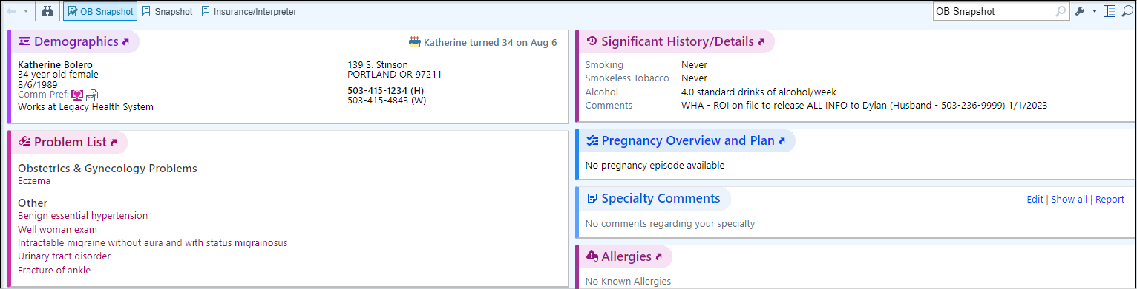

- Demographics – Patient Identifiers: Age, Sex, Address, Phone #’s, etc.
- Problem List – Patient’s current problem list.
- Care Team – View patient’s PCP and other Care Team Members
  - Examples: Social Workers, Nutritionist, and Behavioral Specialists.
- Health Maintenance – Care Gaps identified by patient’s age, sex, and documented problems.
- Vitals from encounters over the last 365 days – Saves time from having to jump into Chart Review just to find recent vital signs.
- Since Your Last Visit – Encounters with WHA
- Immunizations/ Injections – Documented Immunizations
- Preferred Pharmacies – Patient’s Preferred Pharmacy information.
- Medications – Patient’s current medication list.
- Allergies – Patient’s current documented allergies.
- Specialty Comments – Place to document specialty specific information (OB/GYN specific for WHA, example: Patient had a miscarriage on 1/3/2020)
- Significant History/Details – Tobacco and substance use history
Other reports are available that you may want to reference for different patients.
Follow the steps below to make these reports as speed buttons on the report toolbar.
- On the far-right side, click the wrench.
- Click Add or remove buttons from toolbar button.
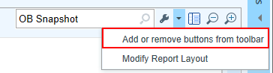
The first field has a Magnifying glass or what Epic calls a Selection Tool, this is a visual indicator that there is a list to select from. To shorten the list, type in the first part of the name of each report and press Enter to allow for quick selection.
Review the following Reports: These have been customized by clicking the wrench.
  - WHA Pregnancy Episode – Summary of patient’s pregnancy episode
  - Snapshot-Patient – Summary of current documentation on the GYN patient.
  - Visit Orders – Way to view all orders and results from today’s visit.
  - AMB facesheet – Demographics, Insurance information, PCP number, Contact information
Card Viewer
- Click Show Tasks button on the far right.
This is a section that allows you to view and take action on certain types of messages/ “Tasks” for:
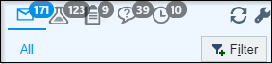
- All
- Results
- Communications such as Patient Calls, also known as Telephone Encounters.
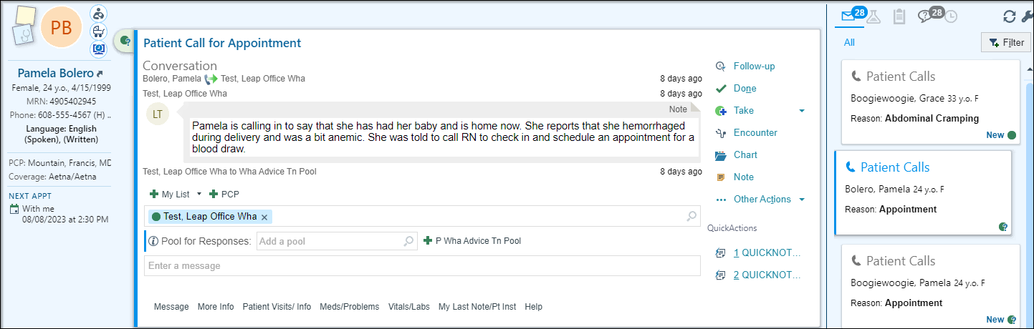
- Click Return to Schedule to collapse the section.
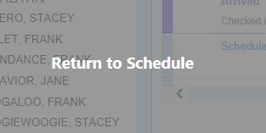

Module 3: Chart Review

Exercise 1: Getting up to speed on your patient

Scenario: The Schedule shows that Gretchen is Arrived and waiting in the lobby. First you will want to get up to speed on what is going on with the patient.
  - Single-click on Gretchen name.

From the appointment notes, you see that she is coming in for a Wellness.
  - Review the Snapshot report for this patient.

You see that she is due for some Health Maintenance.
- Next, Click Chart 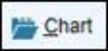 above calendar.

The patient workspace tab opens. Epic allows you to have up to 4 patient’s charts open at the same time. To close click the X (do not do this now).
  - Verify you have the correct patient’s chart open by reviewing information in Storyboard.
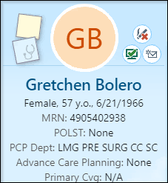

Storyboard
In a patient’s chart, Storyboard appears on the left side of the screen, and activity tabs appear along the top of the screen.
- Hover over any item in Storyboard to see more.
- Click information in Storyboard to jump to an activity to see more detail or take action.
- Click the back arrow to get back to where you were.
- Use the Chart Search to find the information you’re looking for. For example, enter urine micro to search the patient’s chart for prior labs results.
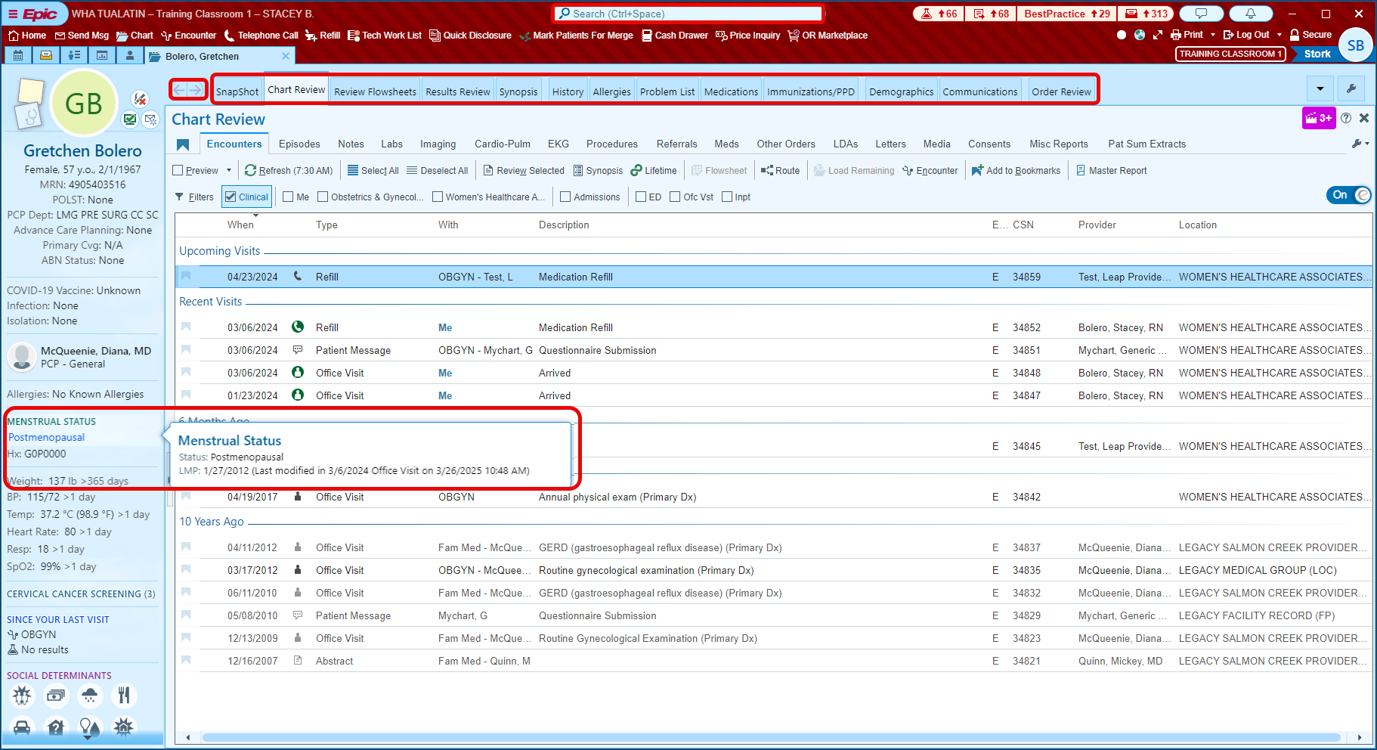
Storyboard presents information in layers. The general rule is, more basic information is towards the top and more specialized information is towards the bottom.
You can glance at it for basic answers to your questions, hover to see more information and click to take action.
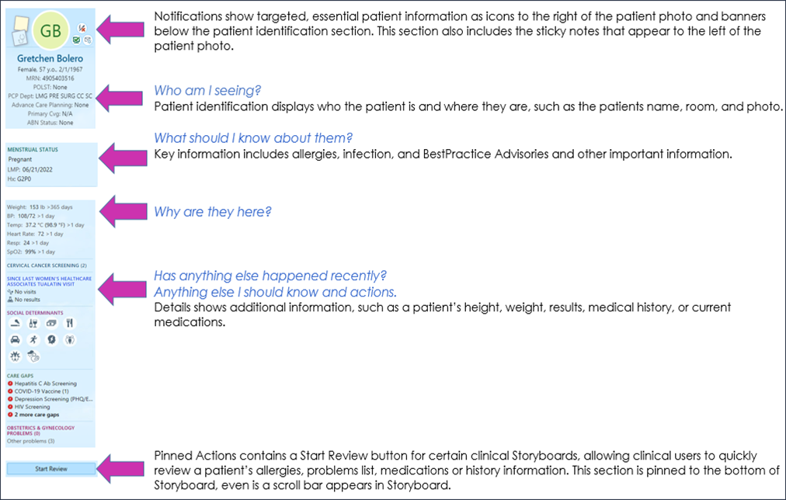
Create sticky notes 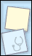 to leave reminders for yourself.
Suggestions: hard to pronounce names, and/or big life events. Sticky notes appear in a floating window that you can minimize or close as needed. Note: A sticky note is a piece of the chart that no one else will see, unless directed to give a copy of chart for legal or court purposes.
Let’s add a note that she will be going back to school to finish her Master’s in Teaching.
  - Click the blue Sticky Note icon  to leave a note in the patient’s chart that you and other providers in your specialty can see.
  - Click the yellow Sticky Note icon 
  - Drag the window down to an open section of the workspace.
  - Type in note about Receiving masters in teaching.
**Note: It’s recommended to add dates to comments in this box. This will help keep a good timeline of what is going on in the patient’s life and make building rapport easier.**
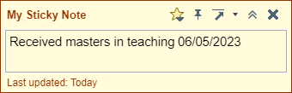
  - Click the chevrons to minimize this note or the X close the note entirely. Clicking the arrow moves the note to the upper right corner of the workspace.
  - Gray lines 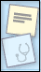 indicate there’s text in the sticky note. Hover to read the note, or click to edit it.

To open Chart Review, click on Chart Review in the list of activity tabs.
Chart Review activity tab: 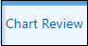
- Encounters tab: This section is where you can find all encounters, we have with the patient. This includes telephone, office visit, orders, patient emails.
- Locate the Last annual visit. (5 years ago, section)
  - Single click for Preview of report.
  - Double click to see the report in almost full screen.
There are Bookmarks and default filters that sort information by selecting or unchecking the checkbox.
- Episodes tab: Episodes are events to which services provided can be linked. Common uses for episodes are care management, worker’s comp, and, of course, pregnancies. Refer to the episode tab to see all services provided for a specific episode.
- Notes tab: Able to filter or view different note types separately, documentation from all encounters.
- Labs tab: All lab test orders and results from all encounters, procedure notes, op reports, etc.
- Imaging tab: All imaging orders and referrals (excludes external imaging orders
- Referrals tab: Where all referrals live, including external, internal, and referrals for external imaging (fax referral orders from here, but not imaging orders)
- Meds tab: Defaults to show patient’s Current Medications. Deselect to review all historical medications prescribed or documented in the chart.
  - Uncheck the Current Meds Only filter to see Historical Meds.
- Other Orders tab: Route external imaging orders from here after provider has co-signed them. Orders for Durable Medical Equipment (DME) reside in this tab as well.
- Letters tab: Epic generated letters printed or sent to patients are in this tab
- Media tab: All scanned documents and images uploaded into the patient’s chart. As documents get scanned, it is critical to add comments for searching capability.
- Consents tab: All documentation that has been electronically signed (i.e. consents)
- Misc. Reports: Allow you to review additional information:
  - Routing Hx,
  - My Chart Report (a report for all MyChart communications)

Now that I have shown you the long way to review a chart… Let me show you a more efficient way to do so.

Locate the Assistant Bar
  - Type HCG.
- Review the previous documentation.
- Hover to discover information.
  - Click the X to close the workspace tab.

Module 3: Lab Appointment Prep

Exercise 1: Finding & Releasing Lab Orders

It is important to scrub your schedule at least 2 days in advance to ensure lab orders are placed to avoid any delays.

Scenario: Gretchen is coming in for a lab draw. I need to investigate to find out if orders have been placed prior to her appointment.

- Go to the TN LAB, WHA Schedule
- Single click on your Gretchen patient.
- Click the Show Orders button.
This will take you into Order Review to show the open lab orders for your patient.
- Verify the orders are placed by WHA clinicians by reviewing the default order report.

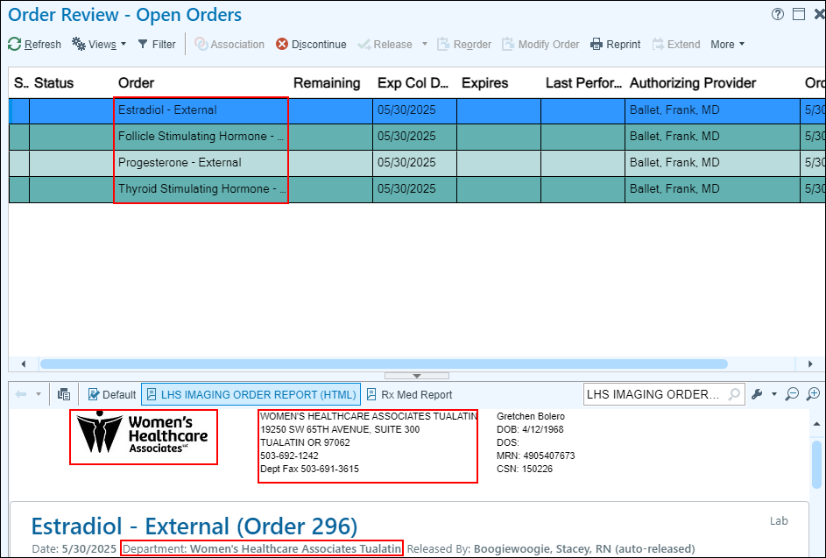
Now that I have verified lab orders are in Gretchen’s chart, I need to add an appointment note to her visit, so I know what labs she is coming in for.
- Go back to the TN LAB Schedule and highlight Gretchen on your schedule.
- Click the Notes button near the right side of the Schedule Toolbar.
- In the text box type: TSH, FSH, Estradiol, Progesterone
- Click Accept.
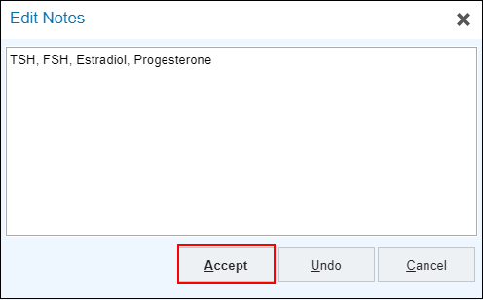
- Notice the Appt Notes section is no longer blank or says See Orders.

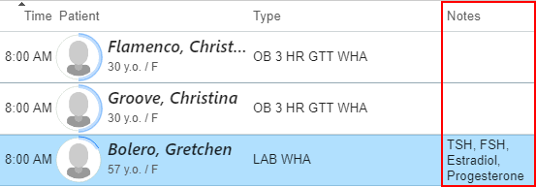
Let’s look at how to release lab orders.

- In the TN Lab schedule, Single click Gretchen’s appointment.
- Click Show Orders to look at her active lab orders.

Time has passed and Gretchen has arrived for her appointment.
- Click the Show Orders button 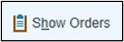 on the schedule.
- Single click on the first standing order.
- While holding Shift on the keyboard, click the last standing order to highlight all three orders.
- Click the Release button
- Click the x next to her name to close her chart.

Exercise 2: 1 Hour Glucose Tolerance Test

Scenario: Jenna is coming in for a lab draw. I need to investigate to find out if orders have been placed prior to her appointment.

- Go to the TN LAB, WHA Schedule
- Single click on your Jenna patient.
- Click the Show Orders button.
This will take you into Order Review to show the open lab orders for your patient.
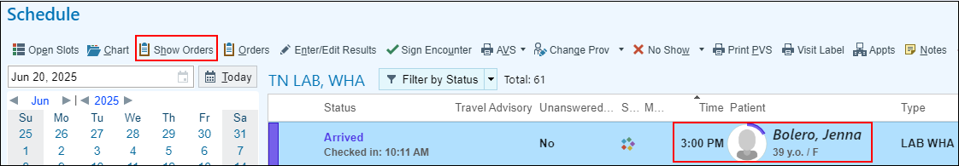
Verify these orders were placed by a WHA provider by reviewing the default order report. Along with the WHA logo, notice that all WHA orders will list the order name along with “- External” at the end.
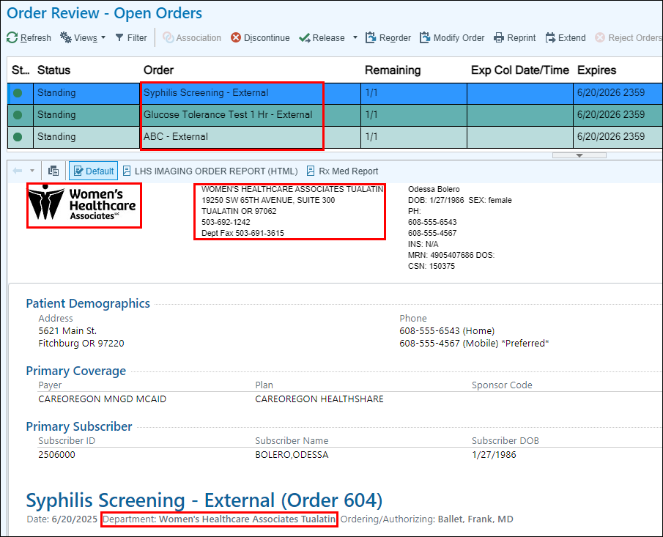
Now that I have verified lab orders are in Jenna’s chart, I need to add an appointment note to her visit, so I know what labs she is coming in for. I notice that Jenna is coming in for her 28-week labs. This indicates these labs are time sensitive. I need to make sure to Add a GTT Start Time to my notes as this will prompt the patient services team to ask and document what time she started her glucose drink so that I don’t miss her timeframe of getting her labs drawn.
- Go back to the TN LAB Schedule and highlight Jenna on your schedule.
- Click the Notes button near the right side of the Schedule Toolbar.
- In the text box Remove: See Orders
- Type: GTT Start Time, ABC, RPR
- Click Accept.
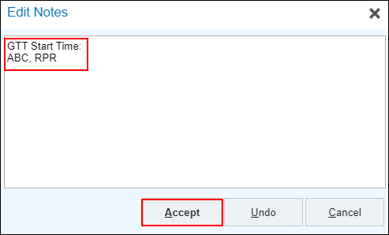
- The Appt Notes section is now updated.

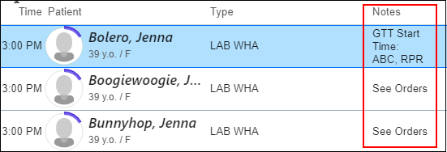
Standing orders are orders that have been placed in advanced by clinicians or support staff for patients to complete at a specific timeframe.
They should only be released once the patient arrives and is ready to be drawn.
Jenna has standing orders for a 1 Hour Glucose Tolerance Test (GTT), an Automated Blood Count (ABC), and Syphilis (RPR).
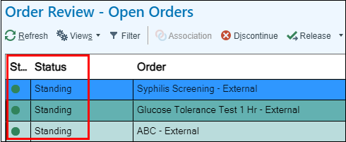
Time has passed and Jenna is ready for her timed draw. This indicates that I can now release her standing orders.
- Click the Show Orders button on the schedule.
- Single click on the first standing order.
- While holding Shift on the keyboard, click the last standing order to highlight all three orders.
- Click the Release button

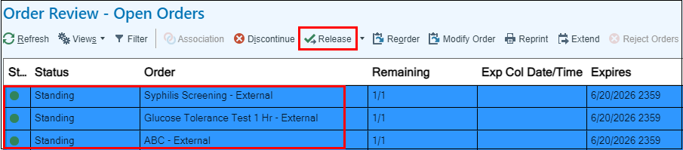
The order status is no longer set as Standing. I can go ahead and print her Orchard Labels.
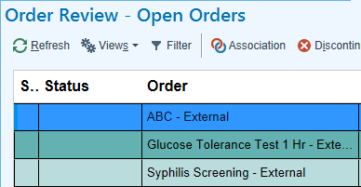
- Click the x next to her name to close her chart.

Exercise 3: Pre Charting – 3 Hour Glucose Tolerance Test
When the patient’s appointment status has not changed to Arrive and is still displayed as Scheduled, it will allow you to access the visit encounter through a “Pre-Charting” option. This allows you to document ahead and spend more time with the patient.
- Check if Christina’s orders are in place.
- Update the appointment notes if additional labs are being drawn.
- Double click on Christina’s chart to open the Pre-Charting activity.
It will bring you into Pre-charting. You have limited sections to document such as: Visit Diagnosis, Problem List, Medications, Orders, Patient Instructions, and Notes.
Before I begin pre charting I first need to ensure lab orders are in Christina’s chart.
- In Chart Review, select the Labs activity.
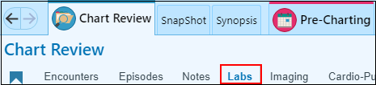
- Orders for a 3-hour glucose test should be placed by a provider or support staff.
Note: If lab orders are not present you will need to reach out to the appropriate support staff member to have those orders placed.
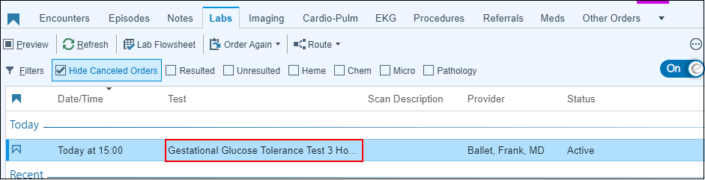
Progress Notes Activity: 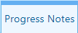
- Initially, the Notes activity will be tucked away. To expand it click the blue Open Sidebar button in the middle of the far-right side of the screen.

- The Progress Notes box will be blank. In the blank space type:
.WHA3HRGTTLABASSISTANT
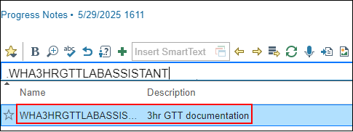
Within the smartphrase there are variables that assist in visit-specific documentation. Press F2 to have the system find the variables for you or you can single click on any of the variables to access the list. F2 through all the wildcards to complete the documentation.
- Fill in as much information using chart review and search tools to find the necessary historical information.
You will fill out the rest of the variables when you are with the patient.
Pre-Charting Activity: 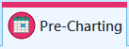
In this section, support staff can add the Visit Diagnosis, Medication Management, Patient Instructions and view the Problem List.
Note: The Problem Lists are managed by the providers only.
- Go to Visit Diagnosis.
- Click on the Problems dropdown.
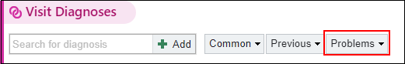
- Select Elevated Glucose Tolerance Test
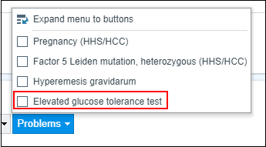
After adding Visit Diagnosis and Progress Note, we have completed the pre-charting process.
You can now exit Christina’s chart.

Module 4: Lab Appointment Documentation

Exercise 1: 3 Hour Glucose Tolerance Test Documentation

Scenario: Christina has arrived for her 3-hour glucose test, so I will call her back (VERIFY it is the correct patient), and bring her to the draw station.
You will receive detailed training on the following 5 steps once you are onsite.
- Print out Orchard labels.
- Once Christina has verified and has initialed her Orchard labels, I will ask her the following questions and take note:
  - How long have you been fasting for? (patients can be fasting 8 – 12 hours, no more than 24).
  - Are you currently diagnosed with diabetes?
- Perform her first blood draw.
- Using the glucometer, run a POC test to ensure that her fasting glucose is less than 126.
Note: If your patient’s fasting level is over 126, click this link for further instructions.
- Once I’ve confirmed her levels are within normal range, proceed to give the patient 100mg of glucola.
Important: Your patient needs to drink the glucola in front of you and will need to finish the glucola within 5 minutes. Take note of the time they began their drink.
- Walk Christina back to the designated area (exam room) where the remainder of the test will take place.
- Instruct Christina to reach out to you if she experiences any nausea/ vomiting.
Experiencing vomiting within the first hour of the test will result in discontinuing the test. Click this link for further instructions.
Now, I will head back to my workstation to complete documentation for this visit.
- Update the appointment notes on the schedule to include the room number and the start time
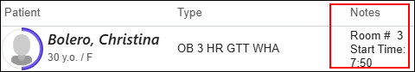

- Double-click your Christina patient to open the visit encounter.
Episode Activity: 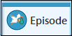
This activity is where you document the “intake” information for the patient.
Document the reason the patient is being seen today.

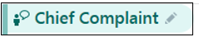
- Click on the Chief Complaint to open the section.
Notice there are present speed buttons available to you. Let’s explore the use of the search field to add a reason for her visit.
- Click in the Add a new reason 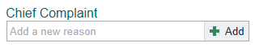 field
- Type: Abnormal Glucose
- Press Enter using your keyboard.
- Click Close.

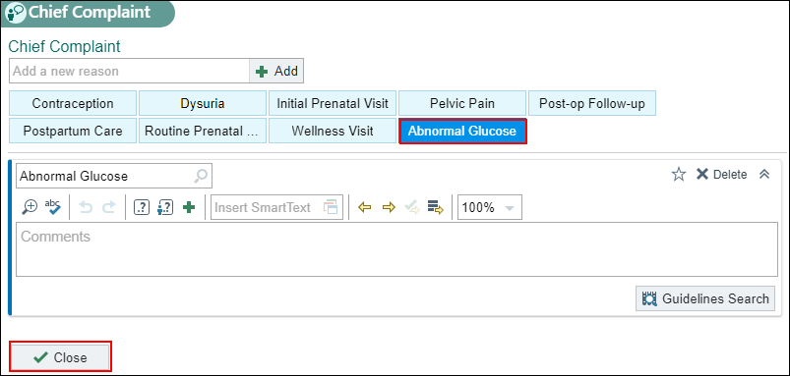

Progress Note: 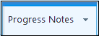
The note is mostly complete as it is constructed incrementally during the patient’s appointment.
There are several features that streamline documentation such as smartphrases to help me complete my note.

For this exercise, you will skip step 7 since you’ve already completed pre – charting in a previous exercise.
- Add the .wha3hrgttlabassistant smartphrase in a blank note.

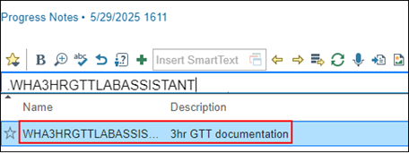
Within the smartphrase there are variables that assist in visit-specific documentation. Press F2 to have the system find the variables for you. F2 through all the wildcards to complete the documentation.

Variables with a circle indicate that you can make one selection from the list. Double click the applicable answer to save and satisfy the variable.
Wildcards are place holders where you can manually enter information by typing once you’ve single-clicked the wildcard or pressed F2 and it is highlighted . You can delete the wild card by pressing backspace if it is not needed.

Variables with a check box indicate you can make one or more selections from the list. Single-click on all that apply, then right-click to save your selected choices.

- Press F2 or click the variables to work through the checklist to ensure it is filled out appropriately.
- Elevated 1Hr GTT documented: Yes
- Patient with current diagnosis of diabetes: No
- Order in place for 3 Hr GTT: Yes
- Fasting: 8 hours
- POC glucose value: 90
Important: The encounter and note need to remain unsigned until all four draws have been completed or if there are complications and the patient or an RN discontinue the test (at which point an RN would take responsibility for the documentation).

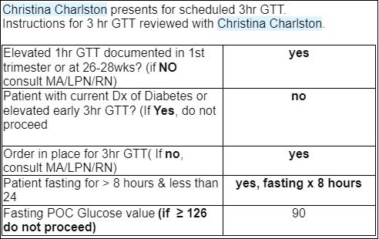

- Christina’s glucose level is under 126, select the appropriate option to continue with documentation.
- Document the time the patient began their drink.
Some time has passed, and Christina is ready for her second draw. At this point, she can now have small sips of 8oz of water.
- Once you have completed all 4 blood draws, finish your documentation.
- Since Christina had no difficulty during her test, select the appropriate option.

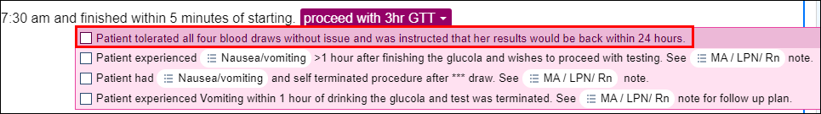
Now that you have completed documenting, it’s time to complete the encounter.
This Visit Activity: 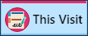
The left column is where a Visit Diagnosis can be placed. It is also where the Problem List, SmartSets and OurPractice Advisories live. The Problem List should be managed by providers only, unless there is a specific protocol that support staff is following.

It is the responsibility of the clinical staff and/or clinician to enter the problem of elevated glucose tolerance test in the Problems List. If you find that the problem is not listed, reach out to a clinical staff member.

- In the Visit diagnosis, select Problems
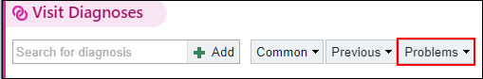
- Select Elevated glucose tolerance test.

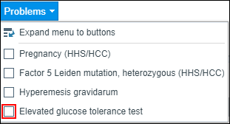
- One of the final few components needed to sign the encounter is the Level of Service located in the toolbar at the bottom of the screen.

- You will choose RN NC chk (PR Nurse Visit No Charge) and then enter the Authorizing Provider, which would be the provider on the 3hr GTT order.

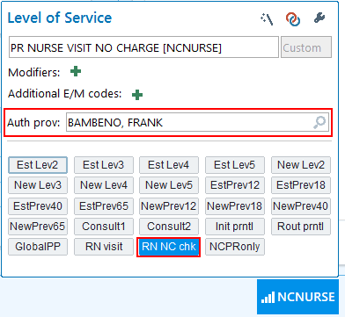

- Click Sign the Encounter 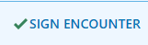 once completed.
Notice how your status changed to signed on your schedule.
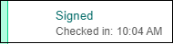

Exercise 2: Nurse Visit & Clinic Administered Medication Documentation
Scenario: Maria has arrived, call her back to the exam room. The medical assistant has entered the order, so everything is in place for the visit. Click this link for more information regarding safe administration of injectable medications.
- Double click the patient’s visit to open the encounter for documentation.

Interpreter Documentation Activity:
When a patient has it documented in their registration that they are in need of an interpreter for the visit there will be a yellow banner in the Storyboard. This banner is a visual indicator that an interpreter is needed, as well as being a button that opens the activity for documentation.

- Click the Needs Interpreter banner to open the Interpreter Documentation activity.

An Interpreter window opens.

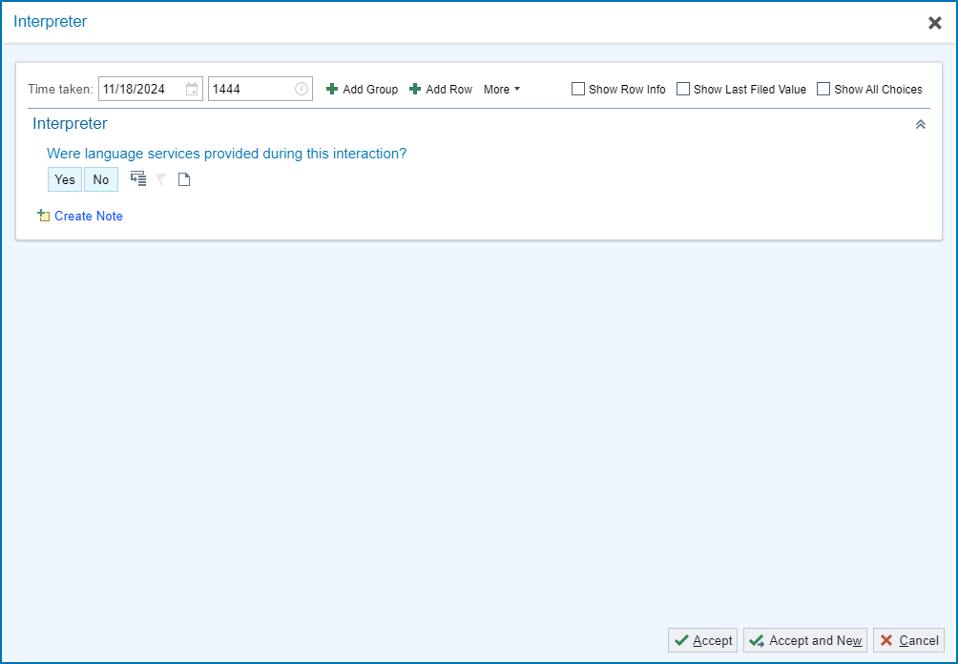
This activity works based on cascading rows , so depending on the answer selected it could trigger more questions. For Grace’s appointment, document that you did use a telephonic interpreter from Linguava named Carrie Smith who is not OHA Certified.
- Were language services provided during this interaction?: Yes.
- Interpreter/Bilingual Staff/Visit provider: Professional Interpreter
- Interpreter/Bilingual Staff/Visit Provider Full Name: Carrie Smith
- Interpreter Mode: By Phone
- Interpreter Service/Agency: Linguava
- Is the interpreter certified or qualified through the Oregon Health Authority? OHA Certified
- Interpreter OHA Registry Number: 012345
- Click Accept once documentation is complete.

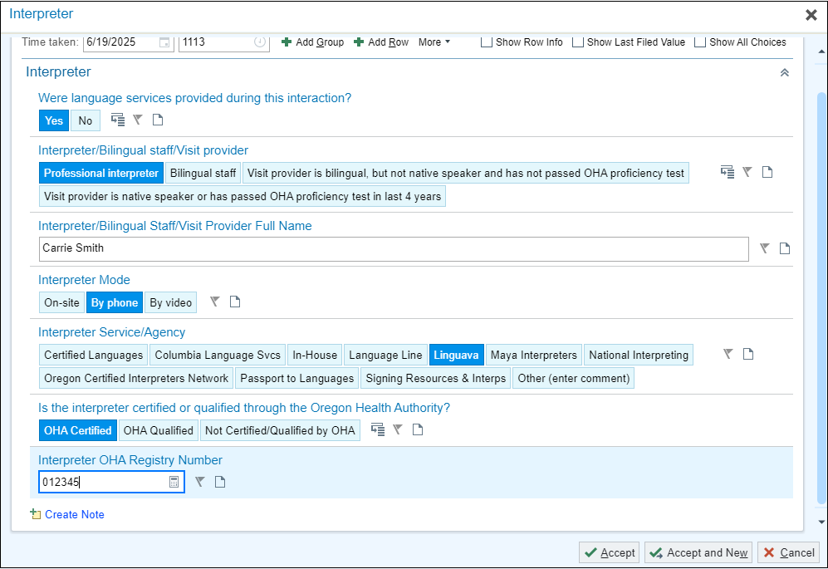

Rooming Activity: 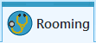
Maria states she is here for a Depo Provera Injection.

- Type Depo Provera
- Press Enter.
- Select Subsequent Injection.
- Close the section.


I will now move on and update the chart with Maria’s current vitals taken today. Remember, most injectable medications require a respiratory reading (respirations or spO2) along with the standard 5 required vitals for every visit.

- BP: 110/74 then add Site, Position, and Cuff size
- Heart Rate: 66
- Temp: 98.2
- Temp Source: tympanic
- Weight: 123lb
- Height: 5f 3in
  - Height Comment: Prior height
- SpO2%: 99
- Click Close

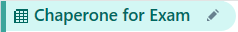

Will Maria need a sensitive exam for this visit? No. Skip this section.



Your patient has not had a period in 6 months and is not reporting any issues with bleeding. Do you need to update this section? No.

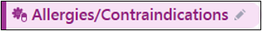

I also need to verify that Maria’s Allergy list is correct and that she is allergic to tree nuts. Maria verifies she does not have any new allergies.

- Click Mark as Reviewed

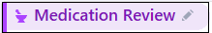
Verify where she likes to pick up her prescriptions. She reports she’s currently taking all medications listed in her chart.

- Mark her medications as Taking, Not Taking, Taking Differently, or Unknown.
- Update Med List Status: Best possible list obtained.
- Click Mark as Reviewed.

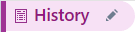
Maria had a recent office visit, and her histories should have been updated by support staff. Skip this section.

Progress Note Activity:
Notice the smartphrase pulls discrete data, which is highlighted in blue. When information is entered into the chart. These data links can continue to pull in information as they are “refreshable”, meaning when you click refresh after new information is entered into the chart that new information will pull into the Note. You can begin documenting the injection into the note.

- In a blank spot in the Progress Note type .WHAHPIINJECTION
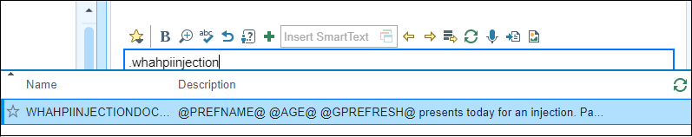

- In the Injection type, double click Depo Provera
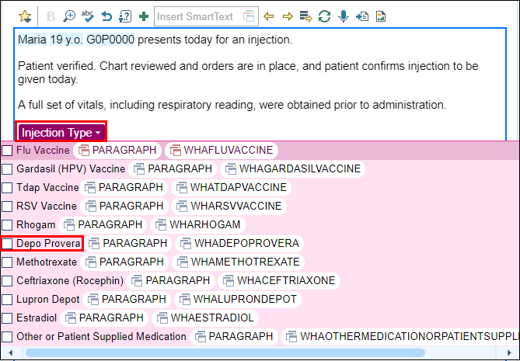
- Press F2 to work through the variables and wild cards available. Utilize the patient’s chart to fill in all the variables.
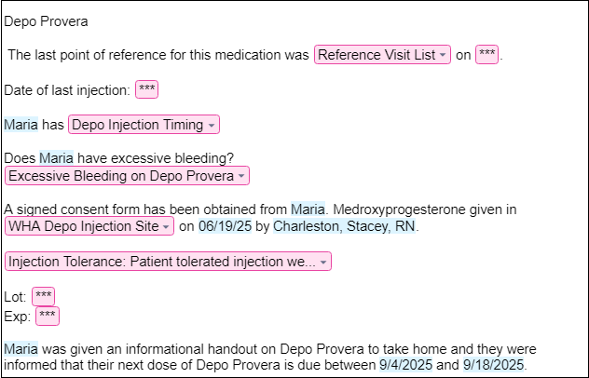

Prior to administering the injection, you want to ensure you are documenting the lot number in the MAR to prevent any documentation mistakes and reassuring you have the correct medication/dose as listed in the order.
Medication Administration Record (MAR) Activity: 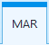

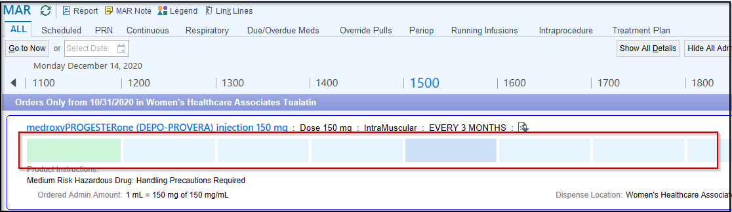

- Click inside one of the boxes to document injection.
- In the Administration Details section, the Action box has a hard stop. Satisfy this to move on.
- Click the selection tool to choose from the list.

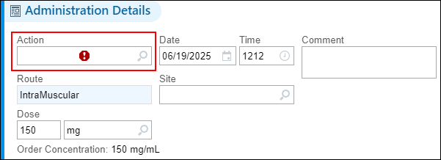

- Select Given.
- A warning box will appear. Click the selection tool and choose Not Given at Scheduled Time.

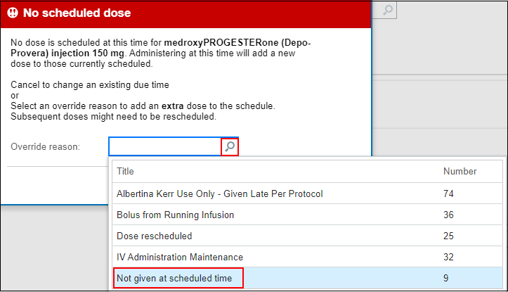
- Click Override. 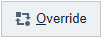
- Enter the NDC: click selection tool and choose the first option on the list.
- Document Lot number: 456612A
- Expiration Date: 9/30/2028

This is the point when the injection would be given to the patient.

- Document the Site of injection: Right Deltoid
- Billing Provider: Frank (Authorizing provider on your login sheet)
- Click Accept.

You can see the documentation information saved.

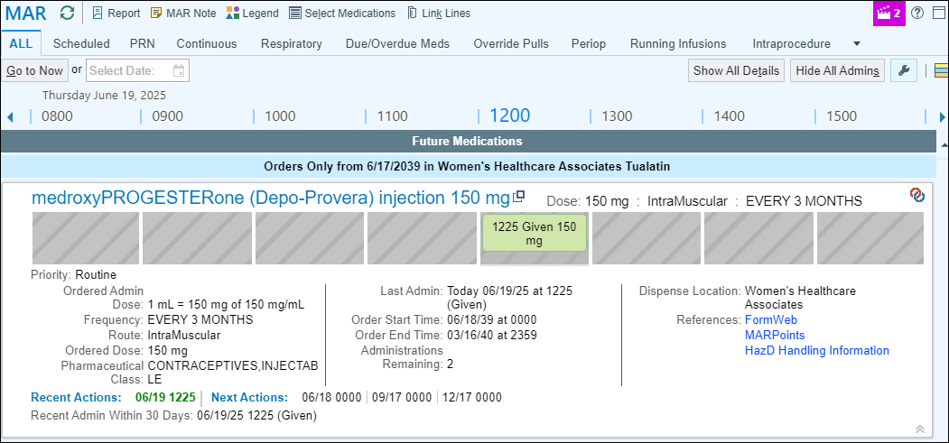

This Visit Activity: 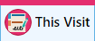
The left column is where a Visit Diagnosis can be placed. It is also where the Problem List, SmartSets and OurPractice Advisories live. The Problem List should be managed by providers only, unless there is a specific protocol that support staff is following.

It is the responsibility of the clinical staff and/or clinician to enter the problem of Contraception in the Problems List. If you find that the problem is not listed, reach out to a clinical staff member.

- Go to Visit Diagnosis and select Problems

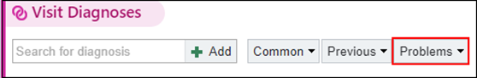

- Select Encounter for surveillance of injectable contraceptive.

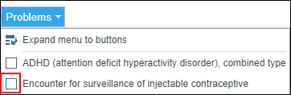

It is time to Wrap Up this visit.

You can use the system to search for visit-related materials that are available. Search for the template for educational materials.

- Type Medroxyprogesterone in the attach reference search box.
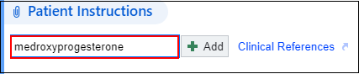

- Press Enter.
- Select the first option: Medroxyprogesterone Injection
- Select Add in Spanish

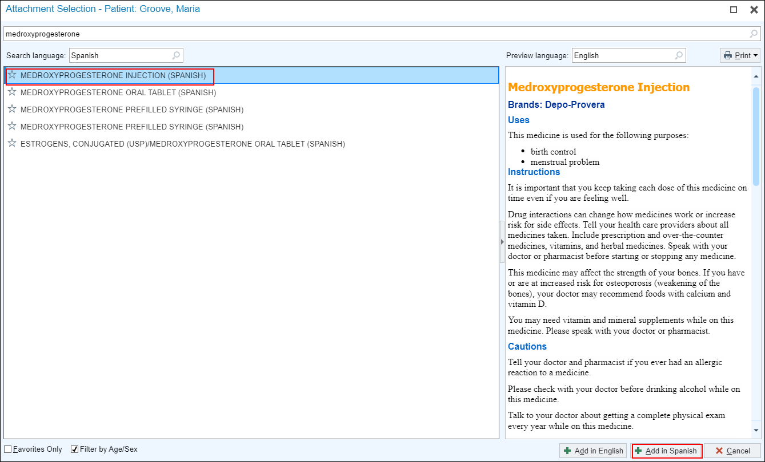

Notice that the instructions are now in the Patient Instructions box as an attachment where you can view, edit, or remove them.

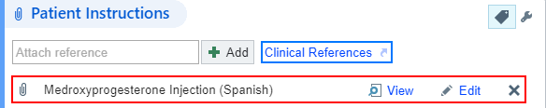

Next, I need to document the Level of Service for today’s visit.

- In the bottom task bar find the LOS field.

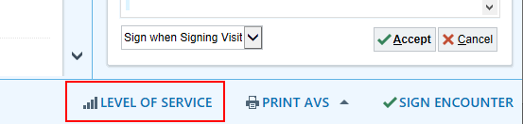

- Click the PR NURSE VISIT NO CHARGE button to select that level of service.
- Auth prov field: type in Frank (your provider) and press Enter, or try “=” to pull in the same provider.

Maria will need to come back in about 12 weeks for her next Depo Provera injection.

- In the number box, type 12.
- Click Weeks.
- In the For box, type: Depo Provera Injection

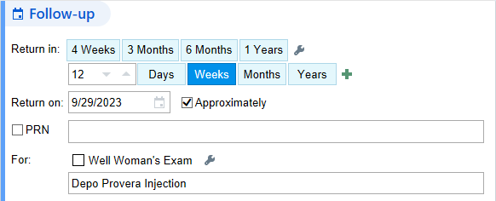

When you get onsite, check with your preceptor on where to locate the Depo Calendar.

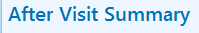
Another part of Meaningful Use measures, is to give the patient a copy of today’s visit. I will now preview the AVS before printing.

- Click Pt Declines AVS (to save paper if the patient is active on MyHealth).
- Click the Sign Encounter button 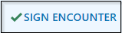

The Schedule will show her appointment as ‘Signed’ 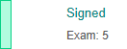

Exercise 3: Documenting an Immunization

Greta was seen in office today and discussed the Gardasil (HPV) vaccine with her provider. The patient has been added to the lab schedule and is waiting in the lobby. You’ll want to document the vaccine information while in the room with the patient before administering.

Now, ensure an order for the HPV Vaccine has been signed.

- Open the encounter
Rooming Activity:
Greta states she is here for an HPV Vaccine.

- Type Immunizations
- Comment: HPV
- Close the section.

Since Greta was already seen for an office visit that day, you don’t need to obtain a new set of vitals. See the screenshot below for previously entered vitals by the support staff.

- BP: 110/74 then add Site, Position, and Cuff size
- Heart Rate: 66
- Temp: 98.2
- Temp Source: tympanic
- Weight: 123lb
- Height: 5f 3in
  - Height Comment: Prior height
- SpO2%: 99
- Click Close

Will you need to document a sensitive exam for Greta? No, you can skip this section.

Do you need to update this section? No.

Since Greta was already seen for an office visit that day, you don’t need to review allergies with the patient. See the screenshot below for previously entered vitals by the support staff.

Since Greta was already seen for an office visit that day, you don’t need to review medications with the patient. See the screenshot below for previously entered vitals by the support staff.

Greta had a recent office visit, and her histories should have been updated by support staff. Skip this section.

Progress Note Activity:

- In a blank spot in the Progress Note type .WHAHPIINJECTION
- Double click on Gardasil (HPV)
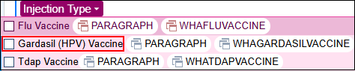
- Press F2 to work through the variables and wild cards available. Utilize the patient’s chart to fill in all the variables.
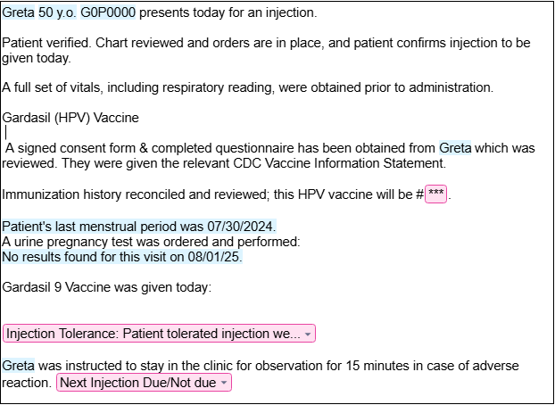

Immunization/PPD: 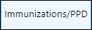
- Click on Immunization activity located under the down arrow in the top right of your screen.
- Click on Administer button.
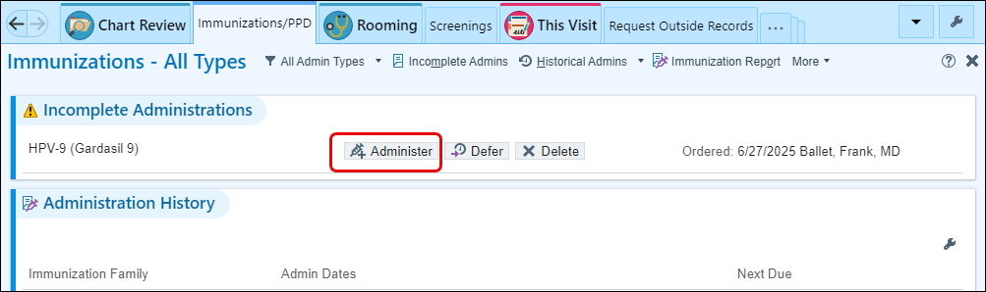
- Lot: X024251
- NDC: 00006-4121-02
- Expiration Date: 10/31/2028

Use the deltoid landmarking technique to administer the injection. Return to the Immunization Activity to complete the documentation and complete the progress note.
- Site: Right Deltoid
- Click Accept.

This Visit Activity:

- Go to Visit Diagnosis

- In the search bar type: Encounter for Imm
- Select Encounter for Immunization from the list.

It is time to Wrap Up this visit.

Skip this section as you will not enter any instructions for the patient.

- In the bottom task bar find the LOS field.
- Click the PR NURSE VISIT NO CHARGE button to select that level of service.
- Auth prov field: type in Frank (your provider) and press Enter, or try “=” to pull in the same provider.

Greta will need to come back in about 2 months for her next HPV vaccine.

- In the number box, type 2.
- Click Months.
- In the For box, type: HPV #2 vaccine.

- Click Pt Declines AVS (to save paper if the patient is active on MyHealth).
- Click the Sign Encounter button

The Schedule will show her appointment as ‘Signed’

Module 5: Access the In Basket

There are multiple ways of accessing In Basket messages.
1> In Basket workspace tab (Top of screen) 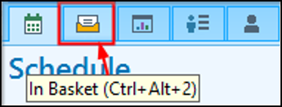
Access all messages and activities.
2> In Basket Card Viewer (Far right side of screen) 
Access Results, Rx Refills, and Patient Calls folders.
3> In Basket tool bar (top right of screen)
Reflection of current folders statuses in your In Basket

The most efficient way to access any folder specifically is to click on the name of the folder in the In Basket toolbar.

- Click the Staff Message folder name on the In Basket toolbar at the bottom of the window.

Notice how that one click took us into the In Basket activity > Staff Message folder> Ready to review the messages.

Exercise 1: In Basket Functionality Demo
At this point, please do NOT click on anything so that I am able to show you this activities functionality.
Let’ browse the Home screen to get an overview of your work before diving in.
First notice, new activity buttons specific for work in the In Basket.
- Home – The main screen to help you stay on top of tasks.
- Refresh – Manual refresh for the In Basket
- New Msg – To send a message to staff/providers.
- New Patient Msg – To send a message to patient using MyHealth.
- My Pools – To connect or disconnect from specific pools.
  - Pools are distribution lists in Epic; we will see more on how this work later.
Then moving over to the left side of the window….
- My Messages – 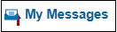
  - Current unresolved work; if there is no work to do, you won’t find the categorized folder.
- Folders – Will appear as you have tasks/work assigned to you.
  - Numbers indicate the number of new/total tasks in the folder.
At the bottom left of the activity, you see…
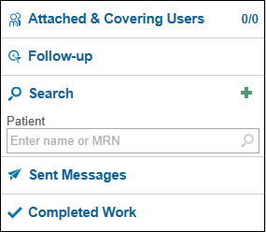
- Attached & Covering Users – Other users In Baskets you may be attached to and mainly used by providers.
- Follow-up – Use to apply flags, postpone or add comments to your messages.
- Search – To search for patients.
- Sent Messages – Messages you have sent during the day.
- Completed Work – Everything you have done/completed in the last 30 days.

While working the In Basket in-between patients, use the buttons on your home screen to quickly jump to New or High Priority messages.



Hover to Refresh or Close the folder.

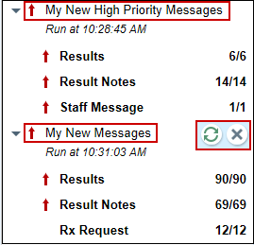

Since you are a part of Pool(s), you can monitor messages coming in and the total number messages using the Pools I’m Signed Into activity to keep work from piling up.

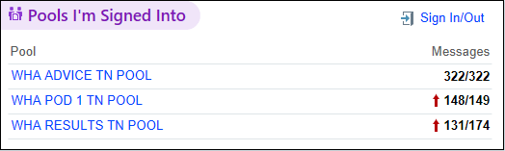

If you are looking for something specific, your Saved Searches can be seen in this activity so you can find the right messages when you need it.

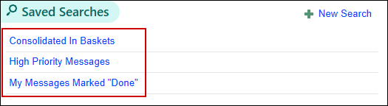

When looking for Sent Messages or Complete Work you can find those in the left Navigator.

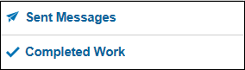

If you want to find a patient you don’t have open, use the Search in the left navigator.

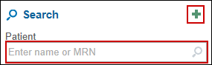
- Click the green plus for additional search options available.
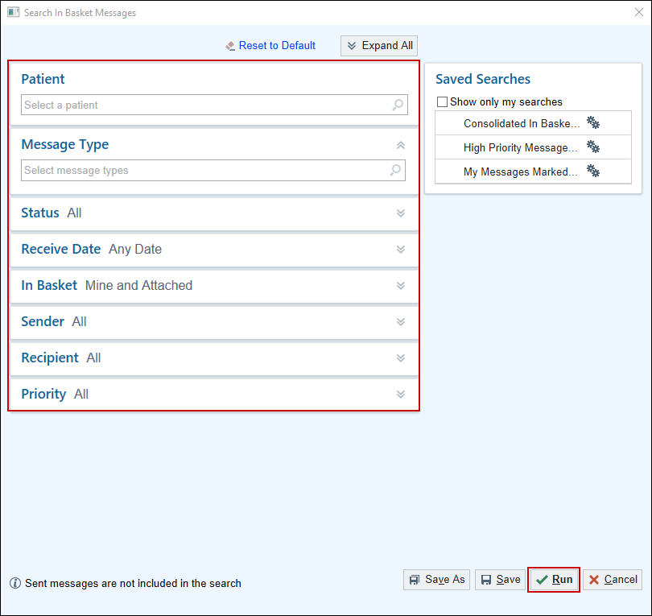
Now I will show you some of the basic functions of completing work in the In Basket.
Consistency is crucial for accomplishing tasks quickly therefore, no matter which folder you’re in, the buttons on the left of the tool bar stay put.

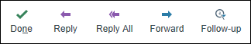

The Follow-up 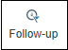 button has a few additional actions like Comments, Postpone and Flags to speed you up even more.

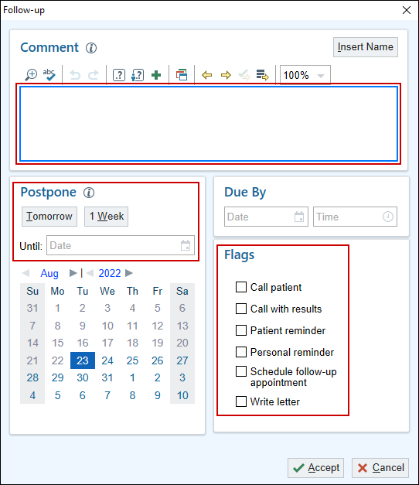

- Click the Insert Name button to add your name, date and time stamp to a comment.
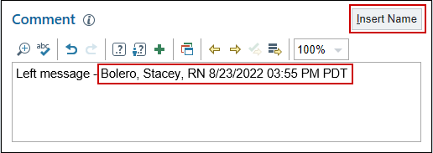
When in a folder, all messages will be listed in the first column or pane. I have a new Staff Message, because the folder & status of the message is New.

I can also see some specific information about this message, such as: Msg Date, Sender and Subject. We will talk about pool workflows here in another exercise.
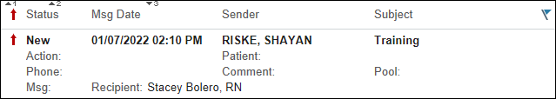
There is also a feature of Epic called “Auto Advance”. Once you have completed a message, Epic will automatically jump to the next message on the list and change its status from New to Read, saving you from having to click to select next messages.

This feature can be turned off by customizing this folder.
- Click the Wrench above the list of messages.
- Click the checked box next to Auto Advance. 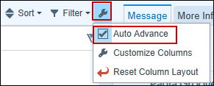

This customization must be done in every folder, but once it is done… You can “Set it and forget it”.
To the right of you screen, you see your Quick Filters as well as customizations and Help before you select on a message in the folder.

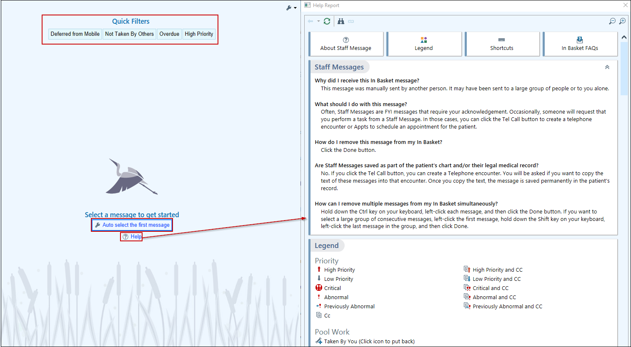
Now I will show you how to complete a message/ task in In Basket.
I will click the Staff Message about Training.

The message itself shows up in the right pane.
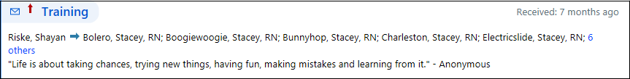
There are activity buttons specific to this type of message/ task to help you complete the work that has been assigned.
For this example, there is no more work that needs to be done, so I can “Done” it.
- Click the Done 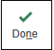 button.
The message status has changed to ‘Done’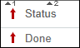.
- Click the Refresh 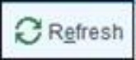 button.

Notice that the message disappears from the folder.

Exercise 2: Create Staff Message
Scenario: Maria is on your schedule for a Depo injection, but there is no order in her chart. You need to send a staff message to the Pod pool for an order.
- Click on New Msg.
- In the To field type: P WHA POD 1 TN POOL.
- Add your pool in Pool for Responses: P WHA LAB TN POOL
- Type: WHA POD TN.
- Subject: Need Order
- Patient: Type in your Christina patient.
- Notes: Patient is coming in for a Depo injection. Please enter the order for this injection prior to the appointment. Thank you!
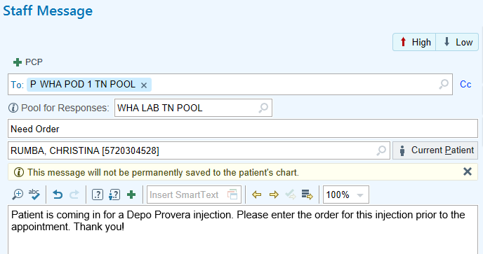
- Go to Call Info, Flags, Dates, and Notifications sections.
- Click on the chevron to expand it.

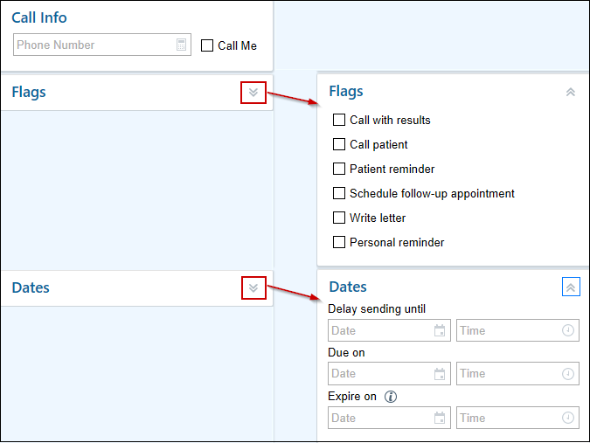
Let’s create a Quick Action before we send our Staff Message.
- Click Save as QuickAction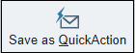.
A warning window opens.
- Click Continue.
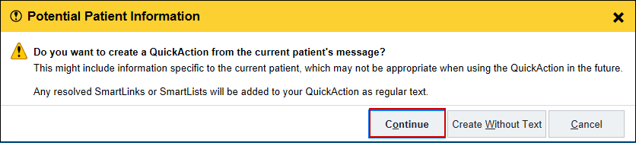
- Button Name: Lab draw.
- Change the note: insert a wild card *** as a placeholder for various labs.
- Click Accept.
Now you can send the Staff Message to Patient Services.
- Click Send 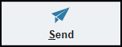

Exercise 3: How to Create QuickActions from the In Basket for Staff Messages and How to Use Them After Creation
- Go into the In Basket.
- Click Manage QuickActions.
- To create a new QuickAction for a staff message, click the arrow next to New QuickAction
- Click New Message
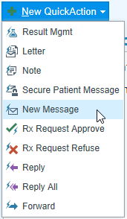
- Create a Button Name
- Enter a Subject
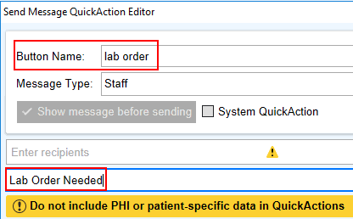
- Add the message. Be sure not to include any patient specific data or PHI in a QuickAction.
**Note: A good way to do this is to type .PREFNAME, then every time you open a new message from a patient’s chart it will automatically add their preferred name.**
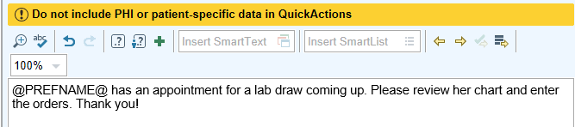
- Click Accept 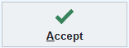
It is now saved at the bottom of your visible QuickActions list. Repeat this process with any other commonly sent staff messages.
To access these QuickActions in a patient’s chart, follow the steps above to create a staff message. Instead of clicking Staff, click the name of the button you need. This will ensure the smartphrase added in the QuickAction will automatically populate, instead of having to retype it in each time a new staff message is opened.
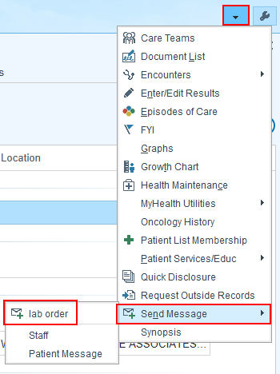
These Staff Messages can be marked High Priority, as needed by clicking the High Priority button in the top right corner of the staff message screen.
